Spot check of recreating daily precip

Daily precip (mm) – average of NOAA files for CAL and FJ

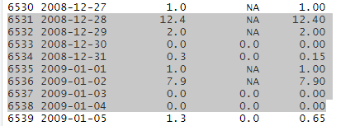

Daily precip (m) – existing input file. Similar but lots of small discrepancies

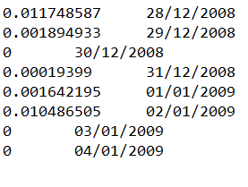

Daily precip (mm) – average of NOAA files for CAL and FJ

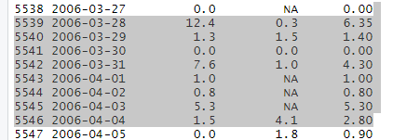

Daily precip (m) – existing input file. Similar but lots of small discrepancies

